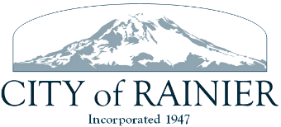

AGENDA
RAINIER CITY COUNCIL
March 12, 2024
Regular Meeting
5:00 pm

Next Ordinance No. 722
Next Resolution No. 552

- Call to Order
- Roll Call

- Approval of Agenda ACTION

- Approval of Consent Agenda ACTION
  - Approval of Regular Meeting Minutes
  - Approval of Claims
  - February 2024 Treasurer’s Report

- Public Comment

- Staff Reports INFORMATION

- New Business
Waterline agreement with Double Mountain Development-Bill ACTION
Comprehensive Plan Update Contract with G&O-Adam Lyons ACTION

- Old Business

- Adjournment ACTION

