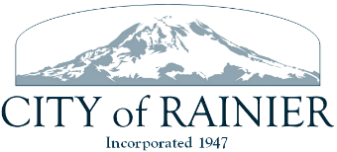

AGENDA
RAINIER CITY COUNCIL
May 24, 2022
IN-PERSON
REGULAR MEETING
5:00 PM (note time change)

Next Ordinance No. 708
Next Resolution No. 547

- Call to Order
- Roll Call

- Approval of Agenda ACTION

- Approval of Consent Agenda ACTION
  - Approval of Regular Meeting Minutes
  - Approval of Claims

- Public Comment

- Presentation by Wade with the Red, White, and Blue Festival scheduled for
July 2, 2022, asking for permission to use the park.

- New Business

- Unfinished Business
We Love Rainier agreement-Bill Cameron ACTION

- Adjournment ACTION

